NATIONAL UNIVERSITY OF MODERN LANGUAGE ISLAMABAD
Lab 05


Submitted to:
Sir Hassan Shah
Submitted by:
Zulqarnain Hassan
Roll No: …………………… SP21379
Subject: …………………… computer network
Department: ……………… BSSE-5-Afternoon
Date: ……………………… 19-11-2024

a. (Switch)
Task 1
Click on pc2 > click desktop tab > click on terminal > click ok (you should be able to access a switch or a Router)
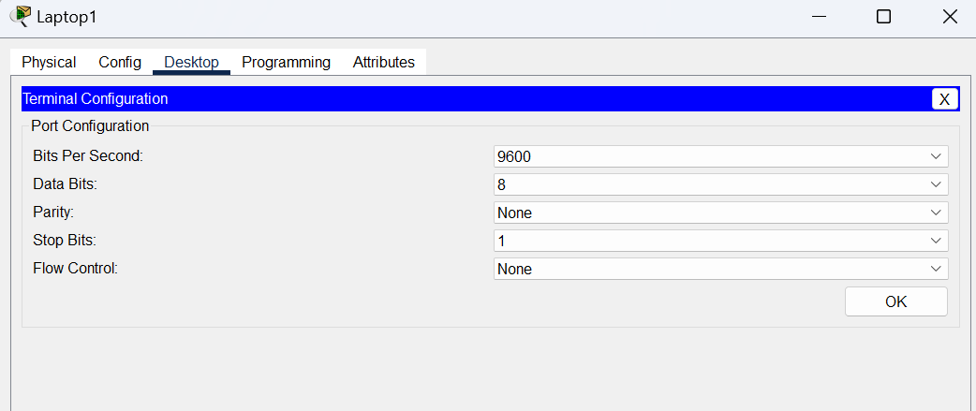

Task 2:
MOTD:
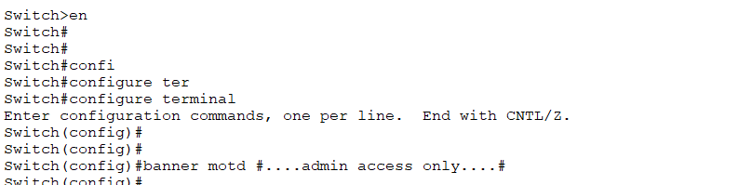
Task 3:
SECURING CONSOLE AND TELNET PORTS:
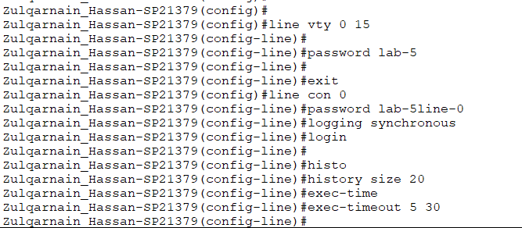

Task 4:
Set Privileged EXEC password:
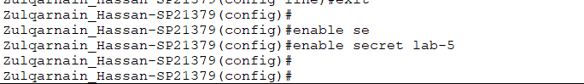

Task 5:
Enable SSH:
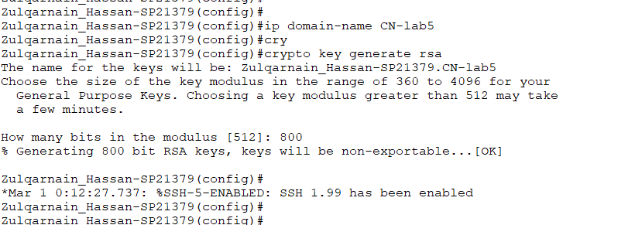

Task 6
Setting SSH version to 2:
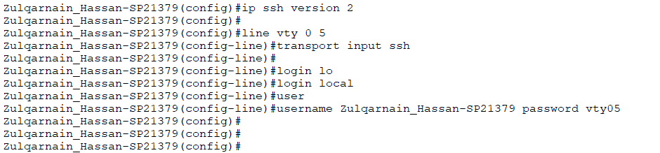

Task 7
Switch Port Access:
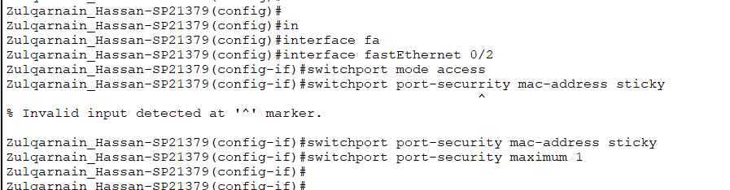

Task 8
Switch Port Security:

b. (Router)
Task 1:
connect to the Router using the console cable.
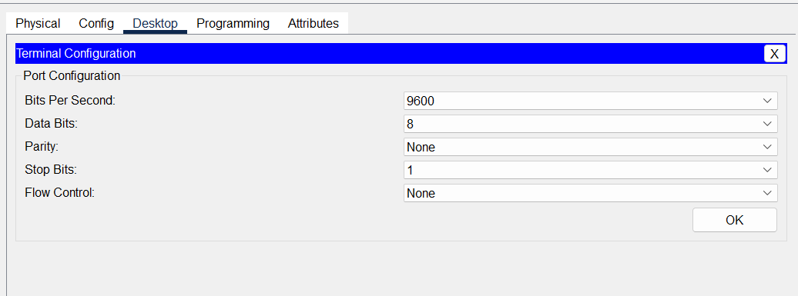

Task 2
MOTD
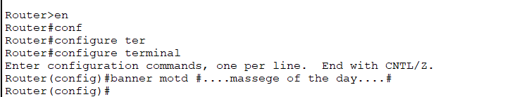
Task 3
Specifies a virtual terminal for remote console access
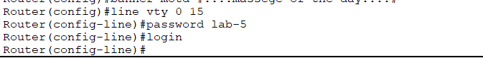
Task 4
Sets the interval that the EXEC command interpreter waits until user input is detected. The default is 10 minutes.
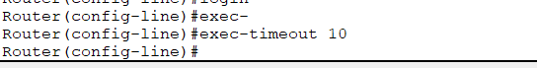
Task 5
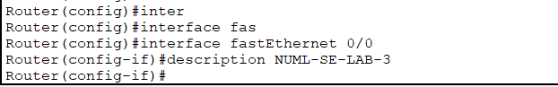

Task 6
